Good water management practices

Worldwide, water for agriculture is getting increasingly scarce. By 2025, 15-20 million hectares of irrigated rice may suffer water scarcity. Therefore, care must be taken to use water wisely and reduce water losses from rice fields. A few principles exist to “get the basics right” for good water management in paddy rice.

Field channels
In many paddy fields, water flows from one field to another through breaches in the bunds. Under such conditions, water in an individual field can not be controlled and field-specific water management is not possible - construction of channels to convey water to and from each field, or group of fields, greatly improves the irrigation and drainage of water.

Land leveling
A well-leveled field is a prerequisite for good water management.
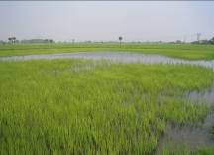
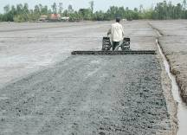
Effect of uneven fields.
Remedy: land leveling!

Land leveling
When a field is not level, water may stagnate in the depressions whereas higher parts may fall dry.

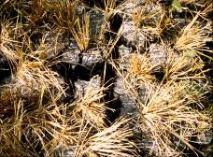
This results in uneven crop emergence, uneven early growth, uneven fertilizer distribution, and weed problems. See the fact sheets on land leveling for more information.
Cracks cause large water losses before soaking

Tillage
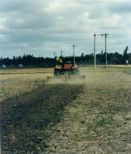
Wet land preparation can consume up to a third of the total water used in paddy rice. In large-scale irrigation systems, synchronizing operations and minimizing the duration of the land preparation period can reduce water use.
Shallow tillage to fill cracks before land soaking

Large amounts of water can be lost during soaking prior to puddling when large and deep cracks are present. A shallow tillage to fill the cracks before soaking can greatly reduce this water loss.

After soaking, thorough puddling results in a compacted plow sole that reduces water losses by percolation. The efficacy of puddling depends on soil properties. Puddling may not be effective in coarse soils, whereas it is very efficient in clay soils that form cracks during the fallow period. Puddling may not be necessary in heavy clay soils with limited internal drainage. In such soils, direct dry seeding on land that is tilled in a dry state is possible with minimal percolation losses.

Bunds
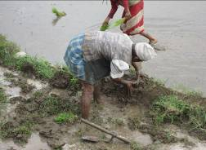
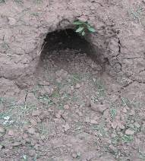
Good bunds are a prerequisite to limit water losses by seepage and under-bund flows. Bunds should be well compacted and any cracks or rat holes should be plastered with mud at the beginning of the crop season. Also, check for, and repair new rat holes, cracks, and porosity caused by earth worms throughout the growing season. Plastic sheets can be used to repair especially permeable parts of bunds.
Good bunds avoid seepage losses
Close rat holes

Ponded water depth
Keeping the depth of ponded water around 5 cm minimizes water losses by seepage and percolation. See the fact sheet on Alternate Wetting and Drying for more information on field water management.

Developed with input from: B.A.M. Bouman and R. M. Lampayan

Find Out More about Water Management in Rice:
Send an email to: r.lampayan@cgiar.org.
Visit http://www.knowledgebank.irri.org.
Download the book “Water management in irrigated rice -
Coping with water scarcity” at: http://books.irri.org/9789712202193_content.pdf
or at: http://www.irri.org/publications/techbulletin/tech.asp?id=10

